

Servitization and innovation

SBA

Content

1. Teaser 3

2. Introduction and module description 3

3. Learning content 3

3.1 Sub-topic 13

4. Summing up 14

5. Content for self-assessment test 14

6. Success case 16

7. 6. Bibliography and further references 17

8. Related training materials 21

9. Keywords 21

10. ESCO competences and skills 21

# Teaser

Did you know that innovation and servitization are key drivers of business growth and resilience in today’s market? Women generally possess significant levels of creativity and innovative capabilities. Therefore, women entrepreneurs can achieve great results when it comes to innovations.

# Introduction and module description

The module helps to understand the concept of servitization and innovation. It strengthens skills of women entrepreneurs in the field of servitization and innovation and enables women entrepreneurs to find the opportunities to introduce servitization and innovation processes to their businesses.

# Learning content

## Sub-topic

The Module includes 2 sub-topics:

1. Servitization
2. Innovation

Sub-topic 1: Servitization

**What is Servitization**

Definition

Servitization is ´***The transformational process of shifting from a product-centric business model and logic to a service-centric approach***´ (C. Kowalkowski et al., 2017). Servitization is not just for product ﬁrms or manufacturers. Companies from the service sector can also introduce servitization in their business.

Figure 1 Servitization process

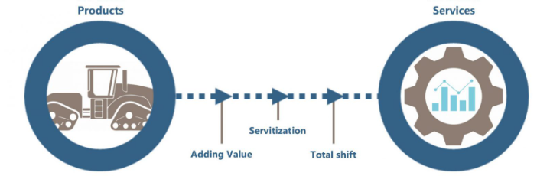

Source: <https://www.scheper.co/labelblue/servitization/>

With servitization, the service becomes a crucial factor while the product is less important. Due to the COVID-19 crisis, the attention has shifted from acquiring customers to customer retention and growth. Through the service, companies can differentiate themselves, and build prestige and brand to attract the customers.

Providing advanced services often requires re-evaluating and potentially redesigning both internal and external aspects of the business. It usually involves a comprehensive reconsideration of external networks that include partners, suppliers, and customers, as well as internal organizational structures and procedures.

For example, Apple, primarily known for selling products such as iPhones, iPads, and MacBooks, has successfully integrated servitization by incorporating a variety of services into its business model. It includes offering services as iCloud where users can store data, photos, and backups on Apple's cloud servers, paying for storage on a subscription basis, or AppleCare providing extended warranty and support services, ensuring customers have access to technical support and repairs.

Before implementation

**Is servitization suitable for your business?** Consider if you are able to reach following goals:

* **Building a company vision focused on selling services** rather than simply offering customer service. Change perspective from traditional customer service to a broader approach focused on selling services. The value that your company delivers to your customers can be changed if you create a vision based on service and experience. Service can become the company´s main value driver by:
* Improving the product to deliver more customer value;
* Adopting the idea of service as a business model.
* **Offering customers targeted and extraordinary experience**. It is necessary to have skills and resources to effectively design, implement, and oversee services. Ensure that an organisation possesses the necessary skills, resources, and expertise to effectively create, implement, and oversee services and deliver high-quality services that meet customer needs and contribute to overall business success. Build a diverse team consisting of members with different skills and backgrounds which can contribute to successful integration of servitization within your company. There is also an opportunity to hire an external consultant who could help you with the servitization process.
* **Understanding customers' needs** over solely focusing on the features of a product. Rather than solely concentrating on the characteristics and functionalities of a product, invest effort in gaining profound insights into what customers truly require and desire. To introduce the servitization in your business, you have to understand the specific objectives your customers aim to accomplish with your product, what other products they use in combination with yours, how often they use it etc. To get this information, you can use data from sales and also data from surveys and interviews.

Pros and cons

There are different factors that foster the implementation of servitization within a business, but there are also barriers and obstacles in this process.

Figure 2 Motivators and obstacles of servitization process

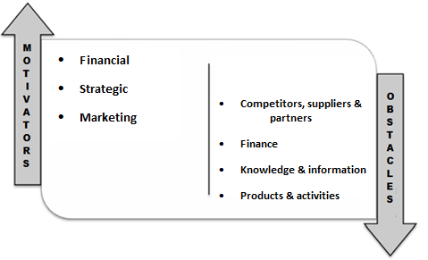

Source: Confente, I., Buratti, A., Russo, I. (2015). The role of servitization for small firms: drivers versus barriers. <https://www.researchgate.net/publication/280728014_The_role_of_servitization_for_small_firms_Drivers_versus_barriers>

MOTIVATORS:

* **Financial**: higher levels of profitability and stability of income in long term;
* **Strategic**: acquisition of the competitive advantage and use of services to differentiate offers and create valuable competitive opportunities;
* **Marketing**: boosting/enhancing product sales by adopting services. From the marketing viewpoint, services play a crucial role in fostering customer loyalty by encouraging repeat purchases. It also provides opportunities for increased interaction with customers, allowing companies to offer additional products or services.

OBSTACLES:

* **Competitors, suppliers and partners**: challenges in guaranteeing coordination and collaboration among various actors of a competitive environment;
* **Finance**: required financial resources that could occur in the beginning of the process, unexpected costs if the service strategy is not well understood or considered;
* **Knowledge and information**: potential need to build trust of customers to ensues their understanding of services´ added value comparing purchasing products;
* **Products and activities**: when providing services, products, and activities might lead to additional workforce that can be expensive (more than products manufacturing).

Levels of servitization

Figure 3 Levels of servitization

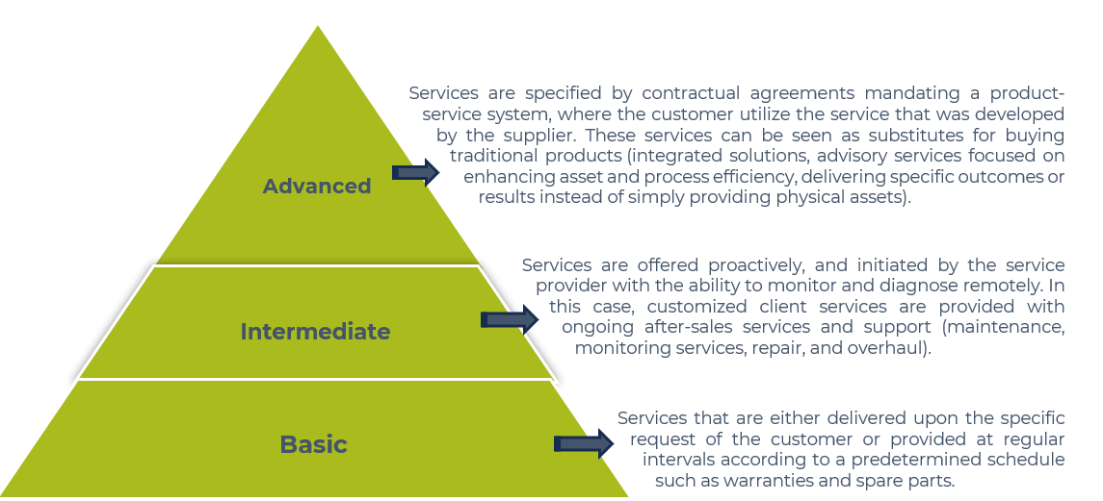

Source:: Author elaboration from the article “The Three Levels of Servitization: Base, Intermediate, Advanced” available [here](https://www.esa-automation.com/en/the-three-levels-of-servitization-base-intermediate-advanced/) and the article “What are the Three Levels of Servitization?” available [here](https://www.exorint.com/exor-innovation-blog/what-are-the-three-levels-of-servitization).

Methodology for the implementation

Companies implement a servitization strategy to provide integrated solutions for customers and create new value. According to the **Service Innovation Methodology developed** under [THINGS+ project](https://www.interreg-central.eu/Content.Node/THINGS-.html), the servitization can be implemented in 5 phases:

1. **Phase 1**

The main task in the first phase is to **recognize servitization opportunities** for your company according to its current capabilities and expertise and assess the company’s capabilities and existing offer.

* List the already existing products and services offered by the company and choose the most relevant product/s based on an assessment of its financial relevance (considering income and profitability), perceived importance, and resulted impact (considering the previous two criteria).
* Analyse past strategies adopted by your company (successful and unsuccessful) to identify key competencies of your company and business circumstances that can ensure success for your company.
* Use the [Product Attributes Map](https://hbr.org/1996/05/discover-your-products-hidden-potential) to align your offering with customer preferences and improve your competitive position in the market. It enables you to identify crucial features of the company's portfolio, which can then be categorized according to customer perception.
* Elaborate the [Value Proposition Canvas](https://www.strategyzer.com/library/the-value-proposition-canvas) to refine the development of a product or service, as well as its unique features, by considering how they impact the customer. Use the following steps:
* Try to better understand your customers and start by defining their problem (s) and goals ([Jobs To Be Done](https://strategyn.com/jobs-to-be-done/)). Adopt a customer-centric approach and focus on targeted customer segments that you can reach with your service. Market segmentation should be based on the circumstances and challenges (problems) that your customers are facing. Define your customers, the reasons leading them to buy your product, and the circumstances under which they buy it (who, why, and when buy your product).
* Solve difficulties that arise from performing the Job To Be Done. Identify the features of the company's products and services that can help you do so by [Value Map](https://www.strategyzer.com/library/the-value-map). The Value Map also serves as a tool for defining the features of a company's products and services offering benefits to the customers.
* Map the competition’s offerings and prepare a list of alternatives and relevant services - identify and describe the competitors, substitutes, and workarounds for a certain job to be done without being explicitly focused on the same industry.  By shifting the focus to solving customer problems, new opportunities can be unlocked and market reach can be expanded beyond traditional boundaries and overlooked markets.
* Make a comparison of competitors´ solutions and try to understand why customers select a particular solution under specific customer circumstances using strategy canvas enabling you to predict customers´ behaviour and prepare a competitive strategy focusing on alternatives instead of competitors.

1. **Phase 2**

Focus on a **comprehensive understanding of your customers and their needs from an external perspective**, emphasizing a customer-centric approach.

* Further elaborate the customer segments considering different features such as social, demographic, geographical, and evaluate the groups of customers based on their value to identify how the best current customers are segmented. Strategic targeting and prioritization in customer segmentation help you to determine the allocation of resources.
* Select and concentrate your effort on the segment(s) that offer the greatest potential for success. Personify the customer segment - create a profile of a customer ([customer persona](https://econsultancy.com/customer-personas/)) by focusing on a real person (specific individual) that represents the customer segment.
* Map the whole process of using the product or service including tasks and behaviour of different customer segments on various stages and create the [Customer Journey](https://columbiaroadcom.medium.com/why-and-how-to-create-a-customer-journey-map-download-free-template-b832a614cbe0).
* Find the opportunities for servitization and asses them from the customer’s and the company’s perspective considering benefits for customers and the attractiveness for the company.
* Develop the servitization concept based on the most perspective opportunity considering its applicability, feasibility, and sustainability from the company viewpoint. Provide the description of the new service and key elements needed for the implementation.

1. **Phase 3**

**Develop the servitization project** and deal with the challenges that impact the company.

* Describe key elements of the business model and identify those that will be added or changed/updated using the [Business Model Canvas](https://www.strategyzer.com/library/the-business-model-canvas).
* Make sure that your organization is able to deal with the challenges and changes that accompany the implementation of the innovation. Use the [Resources Processes and Values Framework](https://thebusinessprofessor.com/en_US/mgmt-operations/resources-process-values-framework) to identify the elements that will change, and define the change and expected results.

1. **Phase 4**

Formulate an implementation strategy and aim at the **commercialisation of the servitized product.**

* Prepare a short strategy plan ([One Page Strategy](https://www.slideshare.net/slideshow/strategija-na-a4-predavanje-2009/1347603)). Create the strategy by answering questions ´What?´ referring to Success and Goals and ´How?´ referring to Strategies and Activities.
* Prepare the [List of Assumptions](https://iveybusinessjournal.com/publication/strategic-assumptions-the-essential-and-missing-element-of-your-strategic-plan/) based on the One Page Strategy. Assumptions are formulated based on various factors related to the company such as the company’s environment, the capabilities and resources it possesses, and the individuals who are responsible for carrying out specific actions and aspects of the servitization process.
* Specify the details regarding the key implementation activities. Elaborate on those activities and focus on description, responsible persons, resources, deadlines and timeline, and results to be achieved.

1. **Phase 5**

Phase 5 is aimed at further efforts towards international expansion (those activities can be included also in phase 4).

Digital servitization

Currently, with new technologies and artificial intelligence (AI), digitalization becomes very important in business.

* Digitalization helps make products and services more service-oriented by incorporating digital elements, which improves the overall user experience.
* Therefore, digitalization supports servitization by integrating advanced digital features into products, which allows companies to offer more sophisticated and efficient services to their customers.
* By digitising certain features, digitalization reduces the physical nature of an offering.
* Example:
* Digital parking solutions transform traditional manual parking spaces as cameras scan vehicle licence plates, and parking fees are charged electronically.
* Service platform that can servitize existing offerings as the hotel service replacement by the service platform AirBnB.

**The combination of servitization and digital technologies brings the concept of digital servitization,** thatis a comprehensive system integrating both servitization and software systems.

Figure 4: Digital servitization

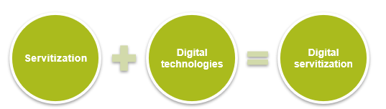

Source: Author elaboration

The introduction of digital servitization may create challenges and increase the complexity of interactions between different players in the ecosystem. It can lead to higher coordination costs and risks, the emergence of conflicting authority structures, and a greater need for platforms capable of addressing these challenges.

**Tip:** Software [Servitly](https://www.servitly.com/) enables you to build and configure all the software components needed to support new product-service offerings. This is your DPS (Digital Product-Service) system.

Sub-topic 2: Innovation

**What is Innovation?**

**Innovation involves the development and implementation of new ideas, methods, or processes that bring positive change, increased productivity or value creation.** It can be introduced across different fields, such as business, technology, science, or arts, and it often leads to improved efficiency, productivity, or value creation.

Definition and types of innovation

According to OECD, innovation can be defined as ´*The successful development and application of new knowledge*´. It includes inventions and various stages leading to the practical implementation of these inventions.

Innovation isn't limited to products. Beyond products, innovation can also involve developing new services, business models, processes, and functions. For example, Starbucks uses its own unique terminology for cup sizes like grande and venti, instead of the usual small, medium, and large. Additionally, they have developed their own payment app.

Based on their scale or intensity, influence on markets and value chains, various types of innovation can be recognized:

* **Process innovation:** Enhancement of production technologies or new improved methods of supplying services and delivering products that can lead to cost reductions. It involves rethinking and redesigning the workflows, procedures, and methods used within an organisation. (Starbucks: introduction of a seamless and customer-oriented ordering and order fulfilment process; using the modern digital technologies, the company has introduced mobile ordering systems that allow customers to conveniently place orders and make payments via smartphones).
* **Product innovation:** Introducing new products to market or enhancing existing ones, which involves modifying their features or attributes (IKEA: selling innovative products in flat-pack format, which improves purchasing and its logistics for customers).
* **Sustaining innovations** - Preserves the level of improvement in features adding value to products (regular updates to smartphone models with improved camera features and processing speed).
* **Disruptive innovations -** Unpredictable improvements bringing significant, unforeseen changes to the markets that appear irregularly. It involves innovations and technologies that help make high-cost or complex products and services affordable and accessible to a broader market (Netflix, introduction of digital music downloads).

Prepare for your innovation journey

Key preparatory steps for innovation initiatives:

1. **Define what innovation means** and ensure it is understood in the same way within your company.
2. **Set concrete objectives** for innovation you would like to introduce into your company, which can be measured and reached.
3. Pay attention to **diversity** **when it comes to** **forming a team**. Build a team consisting of members with various skills and backgrounds that can provide different perspectives as it leads to more comprehensive and effective solutions driving innovation.  Create teams that encompass members from diverse departments within the organisation to foster collaboration and profit from a variety of expertise to achieve common goals and innovation outcomes.
4. **Allocate an appropriate amount of funds** to cover various stages and aspects of the innovation process, including research, development, and implementation.

Innovation process

The innovation process is a structured and carefully managed sequence of strategic actions accompanied by the application of creative and novel approaches. It involves introducing innovative methods, exploring different sources of supply, entering new markets, developing creative products, and reconfiguring organisational frameworks within an industry.

Phases of the innovation process:

1. **Innovative idea creation**

* Actively search for new and revolutionary concepts and ideas that could contribute to the redefinition of products, services, or processes. You can use [Design Thinking](https://designthinking.ideo.com/) or [Creativity Techniques](https://clickup.com/blog/creative-techniques/?utm_source=gpm&utm_medium=cpc&utm_campaign=gpm_cpc_ar_nnc_pro_trial_all-devices_tcpa_lp_x_all-departments_x_pmax&utm_content=&utm_term=&utm_creative=_____&gad_source=1&gclid=Cj0KCQiA5rGuBhCnARIsAN11vgRocA5HWvzyvhd4dPR-KhOWFWE81JFbxohvgpUqAILacFnkWHFC4ycaAr4JEALw_wcB) ([brainstorming](https://www.innovationtraining.org/online-templates-for-brainstorming/) sessions, [mind mapping](https://www.edrawmind.com/article/techniques-for-mind-map.html)).

You can check below mentioned questions that can help you on your innovation journey and see the examples of innovative ideas.

Figure 5: Questions and examples for your innovations journey

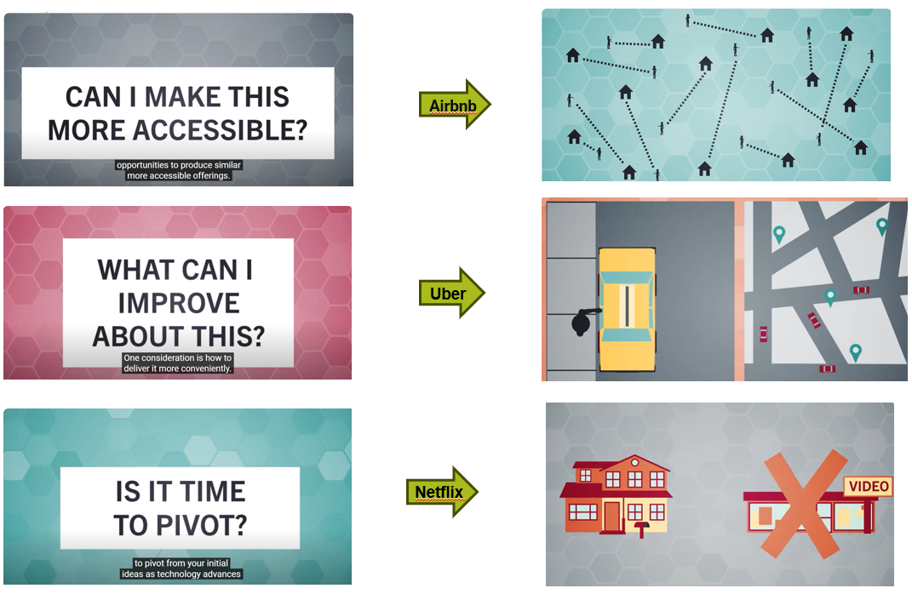

Source: Author elaboration from the video “How to Come Up with Innovative Business Ideas | Business: Explained” available [here](https://www.youtube.com/watch?v=Y_jJ1hsIyd0).

Get inspiration on how to come up with innovative business ideas in this [video](https://www.youtube.com/watch?v=Y_jJ1hsIyd0).

1. **Advocacy screening and experimentation**

* Provide an in-depth analysis, gain information for evaluating feasibility, and explore the potential problems and benefits of the business idea.
* Analyse the customer needs and ensure that the innovation aligns with real-world requirements.

1. **Preparing a solution**

* Create solution-building prototypes and conduct various tests. Transform the idea into a concrete solution.

1. **Marketing and commercialization**

* Produce market value for the created solution. Establish detailed specifications for the idea that are clear and closely aligned with the requirements of the market. Ensure that the developed product or service effectively addresses market needs, increasing its chances of success and creating value for customers.

1. **Expansion and implementation**

* Introduce and spread the idea within the market. Turn the innovative idea into concrete, practical real-world application. Evaluate the innovation's effect on customer requirements, establish criteria for measuring success, and gather valuable feedback to drive ongoing enhancements.

How to boost the innovation process:

You can try various methods to boost the innovation process in your company. Open innovation is used to accelerate the innovation process in companies and various types of organisations. Open innovation helps companies to enhance its innovation process by sourcing ideas both internally and externally. It can help organisations discover new ways to solve problems and challenges while also building a positive reputation even during the crises as COVID-19. Most importantly it can serve as a foundation for future collaboration.

LEGO has successfully adopted an open innovation to improve its product.  LEGO’s approach to open innovation through the LEGO Ideas platform where a community of fans and enthusiasts can submit their own ideas for new products allows the company to crowdsource product ideas while strengthening its relationship with a dedicated customer base.

There are various approaches to applying open innovation in your organisation. One of them is a hackathon.

Hackathon

A hackathon is an event where people from various fields come together to address specific challenges by developing solutions within a set time frame. These events can range in duration, typically lasting from one day to a week, but can also extend over several weeks, especially in an online format. You can organise a hackathon as an internal or external event. An internal hackathon is exclusively for the employees of the company or organisation hosting the event while during the external hackathon the company invites external experts to participate in a competition to solve a specific problem. The challenges in these hackathons often relate to marketing strategy issues or product innovation.

How to organise a hackathon?

1. Select a project to be solved by the participants / present the project to be prototyped.
2. Clearly explain the assignment to ensure everyone understands the goal of the event.
3. Analyse the solutions. (Make a critical decision on whether to continue with the project and, if so, laying out a clear plan for how to proceed.)
4. Form teams and divide the roles within each team.
5. Create a task list and a solution procedure. (Ensure the task list keeps each team member engaged during the event while tasks assigned to one member should last no more than 2-3 hours.)
6. Code, design and prototype.
7. Continuously update and refine solutions.
8. Present the results.
9. Eat and sleep.

You can use a **new** [**tool**](https://hbr.org/2023/09/a-new-approach-to-strategic-innovation?registration=success) **aimed** **at** **assisting company leaders in optimising their allocation of resources toward innovation initiatives.** It consists of two parts: a strategy summary framework and an innovation basket. Leaders begin by defining and understanding the strategy of their unit or organisation and identifying what changes are necessary to achieve it. The identified change needs are then converted into specific innovation objectives and leaders establish their ´innovation basket´ by mapping out each project against these objectives. It helps to exclude projects that are not aligned with the objectives and create new ones that are aligned.

Benefits of business innovation

Innovation can impact your organisation in a positive way as you can:

* Get a competitive advantage.
* Better address a customers’ needs which enables you to attract new customers and maintain existing ones.
* Identify new opportunities for your company, increase its revenue, expand market share, and enhance its overall success.
* Enhance the effectiveness and productivity of your company.
* Be more prepared to handle changes.
* Attract and maintain skilled professionals and talented employees.
* Build sustainable practices and resilience to actively encourage and support the ability of your business to withstand challenges and maintain its operations over time.

Risks and challenges in innovation process

There is a close relationship between innovation and failure. Innovation involves experimentation, trying new approaches, and taking risks in order to push boundaries and achieve progress. Therefore, it is absolutely natural that some mistakes and failures may occur along the way. There are many examples of companies that failed many times before becoming successful, especially those containing innovation. Here you can find some examples of challenges of the innovation process and advice on how to avoid them:

* Failure of an innovation - new technology concept, or product upon market introduction. Smaller-scale tests and launching prototypes that enable post-trial adjustments before mass production are recommended.
* Financial difficulties or constraints as companies allocate resources to support innovations without seeing immediate profits. Expected profit should be evaluated and innovation should be in line with the company's long-term goals.
* Innovation fails to resonate with customer needs and preferences, resulting in poor performance or lack of success in the market. Before investing in innovations, conducting market research is necessary.
* Capacity lack of implementation when searching for strategic partnerships may help.
* Challenges arising within the company's structure and operations following the launch of innovation connected with the possibility of allocating excessive resources to innovation. Therefore, effective planning and resource distribution by top management are crucial.
* Unforeseen challenges that arise based on external factors. Therefore, having a [contingency plan](https://www.forbes.com/advisor/business/contingency-plan/) that helps to overcome these challenges is important.

Innovation and resilience

By effectively managing innovation, organisations can enhance their capacity for resilience, which refers to their ability to maintain high performance and adapt to changing circumstances over time. Innovation resilience refers to how well an organisation can handle the uncertainties that arise during its innovation process by adapting both stability and adaptability playing an essential role as key elements.

**Example:**

Huawei established a special self-critical system known as the Red and Blue Army. The Red Army represents the existing strategic plans and approaches of the company. On the other hand, Blue Army embodies an innovative strategic model or strategy model adapted by competitors. The main responsibility of the Blue Army is to offer alternative perspectives, identify potential issues, and even provide warnings. This confrontative system enables the company's management to get a variety of valuable recommendations. Thanks to this approach, the company can make informed decisions and steer innovation initiatives toward success.

You can find useful tips and suggestions on how to increase innovation resilience in your innovation team [here](https://www.lead-innovation.com/en/insights/5-tips-for-more-resilience-in-your-innovation-team).

Female entrepreneurship and innovation

Women generally possess significant levels of creativity and innovative capabilities. Therefore, it is likely that women entrepreneurs achieve great results when it comes to innovations. However, sectors where women are predominantly active typically lack high-tech innovations.

Women are usually excluded from participating in networks focused on technological innovation. They are commonly perceived as passive participants who merely use or receive innovations, rather than being recognized as innovators. Nevertheless, many examples of innovative women entrepreneurs can be found in history and also nowadays, for example Estée Lauder her innovative approach towards the sale of her cosmetic products or Ninna Granucci, winner of the Prize for Women Innovators for an innovative fermentation process transforming food and vegetable by-products generated by the food processing industry into valuable food ingredients.

# Summing up

Sub-topic 1: Servitization

* Servitization is the transformational process of shifting from a product-centric business model and logic to a service-centric approach. It means that in the servitization process, service becomes a crucial factor.
* Servitization is not just for product ﬁrms or manufacturers.
* Service Innovation Methodology can help you to implement servitization in 5 phases.
* Based on different factors as, for example, technology used and product type, we can recognize 3 levels of servitization: basic, intermediate and advanced. The different levels refer to the varying degrees to which a product can be enhanced with these services.

Sub-topic 2: Innovation

* Innovation involves the development and implementation of new ideas, methods, or processes that bring positive change, increased productivity or value creation.
* There are various types of innovation based on scale or intensity, value chains, and influence on markets.
* Innovation involves experimentation, trying new approaches. Therefore, it is natural if you experience failure during the innovation process.
* To boost the innovation process in your company, you can use various methods, for example open innovation and hackathon.

# Content for self-assessment test

Sub-topic 1: Servitization

Q: What is servitization?

Option A: The transformational process of shifting from a service-centric approach to product-centric business model and logic.

Option B: The transformational process of shifting from selling to buying services.

**Option C: The transformational process of shifting from a product-centric business model and logic to a service-centric approach.**

Q: Which factor does not belong among the motivators for servitization according to this training module?

Option A: Financial

Option B: Strategic

**Option C: Educational**

Q: How many levels can be recognized in servitization?

**Option A: Three: Basic, Intermediate, Advanced**

Option B: Just one (servitization does not have any levels)

Option C: Two: Basic and Advanced

Q: Choose the correct answer for the statement: Servitization is just for product ﬁrms or manufacturers.

Option A: Yes

**Option B: No**

Sub-topic 2: Innovation

Q: What is process innovation?

Option A: Enhancement of production technologies or new improved methods of supplying services and delivering products leading to decrease in the market share.

**Option B: Enhancement of production technologies or new improved methods of supplying services and delivering products that involve rethinking and redesigning the workflows, procedures, and methods used within an organisation.**

Option C: Introducing new products to market or enhancing existing ones, which involves modifying their features or attributes.

Q: Is it possible to enhance the company's capacity for resilience by managing innovation?

**Option A: Yes**

Option B: No

Q: What is the first phase of the innovation process?

Option A: Advocacy screening and experimentation

**Option B: Innovative idea creation.**

Option C: Marketing and commercialization.

Is failure acceptable in the innovation process?

**Option A: Yes**

Option B: No

# Success case

Sub-topic 1: Servitization

Example of the women-led companies that implemented servitization:

* [**EUROtoner**](https://www.eurotoner.sk/)- Rental of printing equipment/devices (Slovak woman-led company)

Adding rental services to the portfolio of the company EUROtoner is a great example of incorporating the servitization concept.

The company rents multifunctional printing equipment/devices. Customers pay just for the renting and material (number of printed pages) without investing a large amount of money in purchasing an expensive multifunctional printing device, whereby the company avoids making an initial high investment.

Renting of multifunctional equipment also includes various related services that the company offers to the customers as complex customer support and servicing. The company created added value for the customers by offering servicing.

The company created a long-lasting relationship with customers and created a source of additional income from equipment rental. Moreover, the company created space for the offer and sale of other additional office equipment.

Watch a video interview with Ms. Mikleová, founder of the company EUROtoner:

Sub-topic 2: Innovation

**Estée Lauder**

[Estée Lauder](https://www.esteelauder.com/blog-article-how-estee-lauder-got-her-start?srsltid=AfmBOopxYH68tw_qLawvlJ_61RqZe7zFcZqvWdtTy27PwGQ0_KpSBEMf) (born Josephine Esther Mentzer) changed the retail consumer experience with her innovative approach. When Estée founded her cosmetic brand in 1946 in America, salespeople usually stayed behind the counter with limited interaction with customers. She challenged this convention by adopting a more direct and personal approach to sales, personally engaging with customers, physically demonstrating product effects, and explaining their benefits.

She introduced an innovative marketing concept by starting to offer gifts after making the purchase. When buying fragrance, customers also got free product samples in the cosmetic bag. This approach led to increased sales and also raised awareness about the products that customers might have not intended to buy.

The strategy of offering gifts with purchases can influence consumer behaviour, spending habits, mindset, and brand loyalty. Moreover, it can create positive emotional bonds with consumers who are likely to make another purchase in the future.

**Ninna Granucci**

Dr Ninna Granucci from France, co-founder and President of [Green Spot Technologies](https://greenspot-tech.com/en/), is one of the winners of the [Prize for Women Innovators](https://eic.ec.europa.eu/eic-prizes/european-prize-women-innovators-powered-eic-eit_en#about). Her company introduced an innovative fermentation process transforming food and vegetable by-products generated by the food processing industry into valuable food ingredients. These ingredients are not only nutritious and flavourful but also have a minimal carbon footprint, making them environmentally friendly. By repurposing food waste through this innovative fermentation process, the company contributes to reducing environmental impact while simultaneously creating high-quality, healthy ingredients for use in food production.

During the fermentation process, minimal amounts of water, energy, and resources are consumed. Thanks to fermentation technology, the company can effectively repurpose food side streams that would otherwise end as waste. The company offers technology that enables adopting a more sustainable approach that can be very attractive in these times.

# 6. Bibliography and further references

Sub-topic 1: Servitization

Baines, T., Bigdeli, A., Sousa, R., Schroeder, A. (2019). Framing the servitization transformation process: A model to understand and facilitate the servitization journey. <https://www.researchgate.net/publication/334990942_Framing_the_servitization_transformation_process_A_model_to_understand_and_facilitate_the_servitization_journey>

Confente, I., Buratti, A., Russo, I. (2015). The role of servitization for small firms: drivers versus barriers. <https://www.researchgate.net/publication/280728014_The_role_of_servitization_for_small_firms_Drivers_versus_barriers>

Interreg Central Europe Things+ project <https://www.interreg-central.eu/Content.Node/THINGS-.html>

Kowalkowski, C., Sklyar, A., Tronvoll, B., & Sörhammar, D. (2022). Digital Servitization: How Data-Driven Services Drive Transformation.  <https://www.researchgate.net/publication/357573234_Digital_Servitization_How_Data-Driven_Services_Drive_Transformation>

Kowalkowski, C., Gebauer, H., Kamp, B. & Parry, B. (2017). Servitization and Deservitization: Overview, Concepts, and Definitions. Industrial Marketing Management. <https://www.sciencedirect.com/science/article/pii/S0019850116303571?via%3Dihub>

Tauqeer MA, Bang KE. Servitization: A Model for the Transformation of Products into Services through a Utility-Driven Approach. Journal of Open Innovation: Technology, Market, and Complexity. 2018; 4(4):60. <https://doi.org/10.3390/joitmc4040060>

Servitization A Model for Growth. How manufacturers are adding value by adding services. <https://www.iedp.com/articles/servitization-a-model-for-growth/>

Servitization: The Changing Face of Manufacturing & Service. <https://www.salesforce.com/eu/blog/servitization-the-changing-face-of-manufacturing-and-service/>

The Three Levels of Servitization: Base, Intermediate, Advanced. <https://www.esa-automation.com/en/the-three-levels-of-servitization-base-intermediate-advanced/>

Van De Velde, J. (2021). Three Perspectives On Successfully 'Servitizing' Your Business. Forbes. <https://www.forbes.com/sites/forbesbusinesscouncil/2021/05/04/three-perspectives-on-successfully-servitizing-your-business/?sh=2ea46270396a>

What are the Three Levels of Servitization? <https://www.exorint.com/exor-innovation-blog/what-are-the-three-levels-of-servitization>

Sub-topic 2: Innovation

Coldwell, C. (2022). Why Failure Is A Necessary Part Of The Innovation Process. <https://www.forbes.com/sites/forbesbusinesscouncil/2022/11/04/why-failure-is-a-necessary-part-of-the-innovation-process/>

[Dahlander](https://hbr.org/search?term=linus%20dahlander), L., [Wallin](https://hbr.org/search?term=martin%20wallin), M. (2020). Why Now Is the Time for “Open Innovation”.  Harvard Business Review. <https://hbr.org/2020/06/why-now-is-the-time-for-open-innovation>

Derya, A. (2022). 5 tips for more resilience in your innovation team. <https://www.lead-innovation.com/en/insights/5-tips-for-more-resilience-in-your-innovation-team>

Dieffenbacher, S. (2023). The Innovation Process: 10-Step Process to Successful Innovation. <https://digitalleadership.com/blog/innovation-process/#What_is_Innovation>

Dieffenbacher, S. (2023). Open Innovation Examples, Definition, and Challenges <https://digitalleadership.com/blog/open-innovation/#Open_Innovation_Examples>

Dieffenbacher, S. (2023). 50 Innovation Examples: Exciting Innovative Ideas in Business.<https://digitalleadership.com/blog/innovation-examples/#2_Ikea_Product_Innovation>

Henderson, T. (2017). Why Innovation Is Crucial To Your Organization's Long-Term Success. Forbes. <https://www.forbes.com/sites/forbescoachescouncil/2017/05/08/why-innovation-is-crucial-to-your-organizations-long-term-success/>

How Estée Lauder’s 1950s Retail Innovation Wrote Beauty’s Sales Playbook (2023). <https://www.pymnts.com/news/retail/2023/how-estee-lauders-1950s-retail-innovation-wrote-beautys-sales-playbook/>

Innovation in business: Importance, benefits, &examples. <https://www.imd.org/reflections/innovation-in-business-importance-benefits-examples/#benefits>

Lechner, L., Hartman, L. (2023). The impact of female entrepreneurship on a country’s innovative performance. <https://gupea.ub.gu.se/bitstream/handle/2077/77846/KBE%202023-149.pdf?sequence=1>

Lopez-Nicolas, C., Nikou, S., Molina-Castillo, F. J., & Bouwman, H. (2020). Gender differences and business model experimentation in European SMEs. Journal of Business and Industrial Marketing, 35(7),1205-1219. <https://doi.org/10.1108/JBIM-05-2019-0194>

Lv, W.-D.; Tian, D.; Wei, Y.; Xi, R.-X. (2018). Innovation Resilience: A New Approach for Managing Uncertainties Concerned with Sustainable Innovation. Sustainability. <https://www.mdpi.com/2071-1050/10/10/3641>

OECD (2023), Competition and Innovation: A Theoretical Perspective, OECD Competition Policy Roundtable Background Note. [competition-and-innovation-a-theoretical-perspective-2023.pdf (oecd.org)](https://www.oecd.org/daf/competition/competition-and-innovation-a-theoretical-perspective-2023.pdf)

Talin, B. (2023). Innovation explained – Definition, Types and Meaning of Innovation. <https://morethandigital.info/en/innovation-definition-innovation-types-and-meaning/>

Tóthová, L. (2021). Hackathon a jeho definícia, spôsob a dôvody realizácie. <https://inova.to/hackathon-a-jeho-definicia-sposob-a-dovody-realizacie/>

Twin, A. (2024). Disruptive Innovation: Meaning and Examples. https://www.investopedia.com/terms/d/disruptive-innovation.asp

What is Process Innovation? <https://innovations4.eu/english/innovation-concepts/what-is-process-innovation/>

Resources:

How to Come Up with Innovative Business Ideas | Business: Explained. Youtube. <https://www.youtube.com/watch?v=Y_jJ1hsIyd0>

# Related training materials

* Module 1: Digital transformation and digital readiness
* Module 2: Access to innovation, finance and local/international market

# Keywords

* Servitization, service, innovation, idea,

# ESCO competences and skills

* Transversal skills and competences
  + Social and emotional skills
  + **Critical thinking**
  + Analytical thinking
  + Problem-solving
  + Self-management
  + **Business management**
  + **Adaptability**
  + Resilience
  + **Creativity**
  + Networking
  + Initiative
  + Flexibility
  + Openness
  + Understanding complexity
  + Cooperation
  + Empathy
  + **Innovation**
  + Leadership

* Skills
  + Technological skills
  + **Product marketing**
  + Digital marketing
  + Digital skills
  + Communication
  + Cooperation
  + Emotional intelligence

* Knowledge
  + **Business management**
  + **Online learning and training**
  + Advertising
  + Cloud computing
  + Big data
  + E-commerce
  + Artificial intelligence
  + IoT
  + Digital literacy
  + Cybersecurity
  + Data mining and analysis
  + **Sustainability**
  + Well-being
  + Climate change
  + Social media management





##### Website:

##### www.refem.eu

##### Email:

##### hetfa_re-fem@hetfa.eu

##### Facebook:

##### www.facebook.com/REFEM0

##### Twitter:

##### @RE-FEM project

##### Linkedin:

##### www.linked.com/RE-FEM

Funded by the European Union. Views and opinions expressed are however those of the author(s) only and do not necessarily reflect those of the European Union or the European Education and Culture Executive Agency (EACEA). Neither the European Union nor EACEA can be held responsible for them.