

**TRAINING FOR WOMEN ENTREPRENEURS:**

**ACCESS TO FINANCE AND INNOVATION**

Authors (Nadja Cirovic, Sanja Popovic-Pantic, IMP)

Content

1. 3

2. 4

3. 7

3.1 7

1. 7

2. 8

3. 10

4. 11

5. 11

6. 14

7. 15

8. 17

9. 17

10. 17

11. 18

12. 18

13. 19

14. 20

3.2 21

1. Creative thinking skills 18

2. Design of the strategic plan for innovation 20

3. Effective implementation of innovative ideas 22

4. 27

5. 29

5.1.1. **Hiba! A könyvjelző nem létezik.**

5.1.2. 29

6. 32

7. 33

8. 36

9. 36

10. 2

# Teaser

**Did you know that one of the biggest barriers for women entrepreneurs is accessing the necessary finance to grow and innovate?**

Our training module, *"Access to Finance and Innovation",* is designed to empower women entrepreneurs with the knowledge and skills needed to overcome these challenges.

**Content and Focus:**

This comprehensive module covers critical aspects such as understanding financial documentation, performing company performance evaluations, and mastering liquidity and credit ratios. You will learn how to manage operational finances and assess creditworthiness effectively. Additionally, we delve into the world of innovation funding, providing insights on how to secure and advocate for financial resources specifically tailored for women’s SMEs. Learn as well about Innovation strategy creation and implementation and how to assess the innovation capacity of the company.

**Interesting Fact:** Did you know that women-led businesses that receive innovation funding are more likely to succeed and grow rapidly than those that don't?

Join us to discover how you can tap into these opportunities and drive your business to new heights.

# Introduction and module description

**TRAINING FOR WOMEN ENTREPRENEURS: ACCESS TO FINANCE AND INNOVATION**

This module equips women entrepreneurs with essential skills in financial management and innovation funding. It covers key topics such as understanding legal documentation, financial statements, performance evaluation, liquidity and credit ratios, and pitching to investors. The module also explores net working capital management, creditworthiness assessment, and profitability analysis. Participants will learn to navigate financial challenges, secure funding for innovation, and enhance strategic decision-making capabilities. The training combines theoretical knowledge with practical exercises, ensuring a comprehensive learning experience Participants will learn how to draft an innovation strategy, implement it effectively, and assess their company's innovation capacity. Their ability to create an innovation strategy will be strengthened by developing creative thinking skills, unlocking their potential to generate innovative ideas.

The training will start with the following topics:

* **Mindset for Creativity** (Growth Mindset, Overcoming Mental Barriers)
* **Divergent vs. Convergent Thinking**

Participants will engage in various creativity techniques, including brainstorming, SCAMPER, mind mapping, Six Thinking Hats, and the "How Might We?" approach.

Next, they will acquire fundamental knowledge on drafting a strategic innovation plan, transforming their innovative ideas—generated through the design thinking process—into a structured plan. This plan will include key elements such as:

1. Defining the innovation strategy
2. Vision, mission, and values
3. Setting clear goals, KPIs, and measuring success
4. Identifying the Job to Be Done and applying the Pain-Gain Model
5. Defining the Value Proposition
6. Creating a Business Model Canvas

Following this, participants will learn how to implement their innovation strategy and, finally, assess their innovation potential using the **INNOVATE methodology**, a self-assessment tool widely used by Serbian SMEs.

The training includes three interactive exercises. The innovation potential self-assessment is provided as a take-home tool, allowing participants to apply it at their convenience.

# Learning content

Objectives: To enable women entrepreneurs to improve access to finance through learning on basic financial management issues, available funds and procedures to apply for innovation funding. To provide them skills of pitching before the investors and learn by doing.

In the innovation segment, participants will learn to:

1. Enhance their creative thinking skills.
2. Develop the capability to create a strategic plan for innovation.
3. Strengthen their ability to effectively implement innovative ideas

## Access to finance

The Access to Finance segment of the Module includes the following sub-topics:

### Introduction to Legal Documentation and Financial Statements for Entrepreneurs[1]

**Introduction to the importance of access to finance:**

• Why is access to finance and innovation crucial for the success of women entrepreneurs?

* Growth
* Development
* Success

• What are some of the challenges women entrepreneurs face in accessing finance?

* Methods of financing
* Collateral procurement

Evaluating company performance involves examining **key financial metrics and ratios** that help determine profitability, efficiency, and overall health. Ratio analysis, such as profitability, liquidity, and leverage ratios, helps entrepreneurs assess how well their business is performing over time, how it compares to competitors, and where improvements can be made. Financial analysis provides actionable insights that guide decision-making in areas like pricing, cost management, and investment.

Entrepreneurs must understand the fundamental legal and financial documents that underpin business operations. Legal documentation, such as incorporation papers, contracts, and partnership agreements, ensures regulatory compliance and mitigates risks. These documents also formalize business relationships and provide legal protection for women entrepreneurs striving to establish a solid foundation.

**Financial statements** are critical tools for monitoring business health. A balance sheet details assets, liabilities, and equity, providing insights into financial stability. Income statements summarize revenue and expenses, offering a clear picture of profitability. Cash flow statements track the movement of funds, crucial for meeting short-term obligations and maintaining operational efficiency.

By mastering legal documentation and financial reporting, entrepreneurs can confidently approach investors, secure funding, and make strategic decisions. For women entrepreneurs, these skills are instrumental in overcoming challenges and achieving sustainable growth.

### Company Performance Evaluation (Financial Analysis and Basic Ratio Analysis)[2]

Evaluating a company’s performance requires systematic financial analysis and understanding key ratios. Financial analysis involves examining trends in revenue, costs, and profits over time to assess growth potential and operational efficiency. Women entrepreneurs, particularly, benefit from these insights to tailor strategies that enhance competitiveness.

Basic ratio analysis simplifies the assessment of financial health. Profitability ratios, such as net profit margin, indicate how efficiently a business converts revenue into profit. Liquidity ratios assess the ability to cover short-term obligations, while leverage ratios measure the company’s reliance on borrowed funds. Efficiency ratios track how effectively assets are managed to generate revenue.

Using these tools, women entrepreneurs can identify strengths, address weaknesses, and make informed decisions. Financial analysis not only fosters strategic planning but also builds confidence among stakeholders and investors.

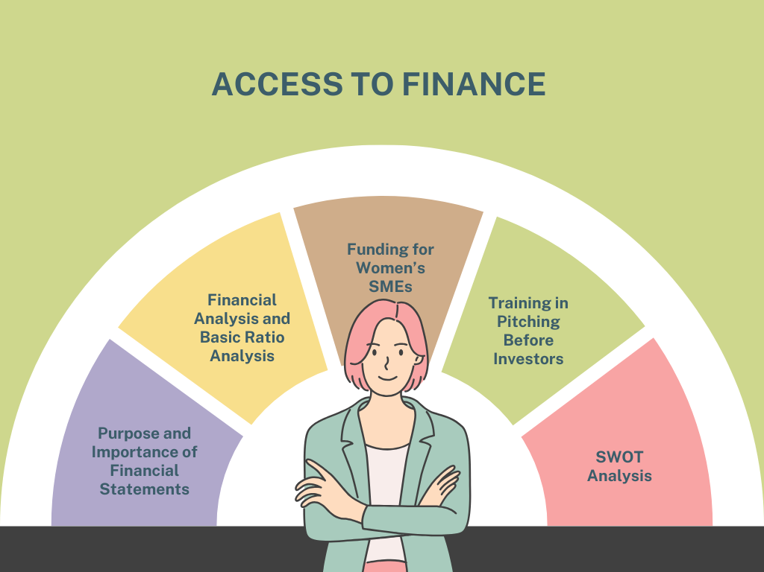

**Figure 1 Key aspects of access to finance. Created by the author.**

### Liquidity Ratios[3]

**Liquidity:** the ability of a firm to pay its short-term debts.

**Liquidity ratios** measure a company’s ability to meet short-term obligations. The current ratio, calculated as current assets divided by current liabilities, indicates the availability of resources to cover debts. A higher ratio suggests better liquidity, while a lower ratio signals potential financial strain.

The quick ratio (acid-test ratio) refines this analysis by excluding inventory from assets, focusing only on liquid resources. This is particularly useful for businesses in industries with slow-moving inventory. For women entrepreneurs, understanding these ratios is vital to maintaining operational stability and avoiding financial difficulties. Also known as the quick ratio, this is a stricter test of a firm’s liquidity. It ignores the least liquid of the firm’s current assets – inventories (stocks).

|  |  |
| --- | --- |
| **Acid-test ratio=** | liquid assets |
| current liabilities |

Regularly monitoring liquidity ratios helps identify cash flow bottlenecks and ensures readiness to meet financial commitments. It also builds trust with lenders and suppliers, facilitating smoother business operations.

### Credit Ratio[4]

**Credit ratios** assess a company’s ability to handle its debt obligations. The debt-to-equity ratio compares total liabilities to shareholders' equity, reflecting the balance between borrowed funds and owner investments. A higher ratio may indicate financial risk but also highlights growth potential when managed effectively.

The interest coverage ratio measures how easily a business can pay interest on its debt using operating income. This ratio is critical for entrepreneurs seeking loans, as it reassures lenders about repayment capacity. Women entrepreneurs can leverage these insights to optimize borrowing strategies and negotiate favourable terms.

By understanding and applying credit ratios, businesses can achieve sustainable growth while maintaining financial stability.

### Innovation funding for women’s SMEs[5]

**Innovation funding** is crucial for empowering women entrepreneurs to drive growth in small and medium enterprises (SMEs). Grants, loans, and equity financing are popular options. Governments and international organizations often provide targeted programs to support women-led businesses in technology, sustainable development, and other innovative fields.

Securing funding requires a solid business plan that highlights the innovative aspect of the enterprise. This includes identifying a unique selling proposition, demonstrating market potential, and outlining the expected impact. Additionally, women entrepreneurs can benefit from incubators and accelerators that offer mentorship alongside funding opportunities.

Women entrepreneurs have multiple financing options available, each with unique benefits and challenges. The choice of funding method depends on the business model, growth stage, and financial needs. By understanding these funding sources, women entrepreneurs can develop a strategic approach to securing capital and building successful, sustainable businesses.

Securing financing is one of the most critical aspects of launching and growing a business. Women entrepreneurs face unique challenges in accessing capital, but there are various funding options available to support their ventures. These funding sources differ in terms of eligibility, repayment obligations, and the level of business control retained by the entrepreneur**. Below is a theoretical overview of the key financing methods**.

1. **Grants (Non-Repayable Funds)**

Grants are financial awards provided by governments, private organizations, or non-profits to support businesses without requiring repayment. They are typically awarded based on specific criteria, such as industry focus, social impact, or business ownership demographics (e.g., women-led businesses).

**Key Characteristics:**

* No repayment required
* Competitive application process
* Often awarded for specific business purposes (e.g., innovation, social impact)
* May have reporting requirements to show fund utilization

📌 *Example:* Government-backed grants for women entrepreneurs support economic empowerment by reducing financial barriers to business entry and expansion.

1. **Business Loans**

A business loan is a form of debt financing in which an entrepreneur borrows capital from a financial institution, online lender, or government-backed program and repays it over time with interest. Loans provide a structured repayment schedule, but they require a solid credit history, business plan, and sometimes collateral.

**Key Characteristics:**

* Requires repayment with interest
* Can be secured (requires collateral) or unsecured (higher interest rates)
* Can be short-term or long-term, depending on the business needs
* Allows business owners to maintain full equity ownership

📌 *Example:* Microloans are a common financing method for small businesses, particularly in developing economies, providing low-interest capital to women entrepreneurs.

1. **Venture Capital (VC) and Angel Investors**

Venture capital (VC) and angel investment involve external investors providing capital in exchange for equity (partial ownership) in the business. Venture capital firms typically invest in high-growth startups, while angel investors are individuals who provide early-stage funding.

**Key Characteristics:**

* Provides significant funding for scaling businesses
* Investors take an ownership stake and may influence decision-making
* Suitable for high-growth, innovative start-ups
* Requires a strong business plan and growth strategy

📌 *Example:* Tech start-ups often attract venture capital funding because they demonstrate high scalability and profitability potential.

1. **Crowdfunding**

Crowdfunding is a method of raising funds from a large number of people, usually through online platforms. It allows entrepreneurs to secure financing without traditional financial intermediaries, leveraging public interest and community support.

**Key Characteristics:**

* Uses digital platforms to raise small amounts from many contributors
* Can be **reward-based** (pre-selling products), **equity-based** (offering shares), or **debt-based** (repayable loans)
* Ideal for product-based businesses and creative ventures
* Requires strong marketing and audience engagement

📌 *Example:* Women-led businesses in fashion or technology often use Kickstarter to secure early-stage funding by offering pre-orders as rewards to backers.

1. **Business Competitions and Accelerators**

Entrepreneurial competitions and accelerators provide funding, mentorship, and networking opportunities to start-ups. Many of these programs focus on supporting women entrepreneurs by offering capital in exchange for participation in mentorship and training programs.

**Key Characteristics:**

* Competitive selection process
* Provides funding, mentorship, and networking opportunities
* Often focused on innovation, technology, or social entrepreneurship
* Some require partial equity in exchange for funding

📌 *Example:* The Cartier Women’s Initiative provides grants and mentorship to female entrepreneurs with businesses that have a social impact.

1. **Bootstrapping (Self-Funding)**

Bootstrapping refers to funding a business using personal savings, reinvested profits, or revenue generated from early operations rather than seeking external financing. This method allows entrepreneurs to retain full ownership and control but may limit growth potential due to resource constraints.

**Key Characteristics:**

* No debt or loss of equity
* Requires financial discipline and careful budget management
* Best for businesses that can generate revenue quickly
* May limit expansion opportunities without external funding

📌 *Example:* Many small businesses start by bootstrapping, reinvesting early profits into growth before seeking external financing.

With the right funding and support, women-led SMEs can scale their operations, penetrate new markets, and contribute significantly to economic development.

### Training in pitching before investors[6]

Pitching is an essential skill for entrepreneurs seeking investment. A successful pitch succinctly communicates the business idea, target market, revenue model, and growth potential. Women entrepreneurs can gain confidence by structuring pitches that emphasize innovation, financial sustainability, and social impact. Key components of an investor pitch include a compelling introduction, a problem-solution narrative, and a clear ask (investment amount and its purpose). Visual aids and data-driven arguments enhance credibility while rehearsing improves delivery and confidence.

Pitching to investors requires clear communication, strategic planning, and confidence. To increase the chances of securing funding, women entrepreneurs should go through structured training to refine their pitch and approach. By refining your pitch deck, mastering storytelling, engaging in mock pitching, and handling investor questions confidently, you can increase your chances of securing funding.

A pitch deck is a short presentation (usually 10-12 slides) that highlights key business aspects. It should include:

1. Problem Statement – Clearly define the problem your business solves.
2. Solution & Unique Value Proposition – Explain how your product/service addresses the problem.
3. Market Opportunity – Show the market size and growth potential.
4. Business Model – Describe how you generate revenue.
5. Traction & Milestones – Present key achievements, customer acquisition, or revenue figures.
6. Competitive Advantage – Explain what differentiates you from competitors.
7. Go-To-Market Strategy – Outline your plan for acquiring customers.
8. Financial Projections – Provide realistic revenue and cost projections.
9. Funding Request – Clearly state how much funding you need and how you will use it.
10. Team – Highlight key team members and their expertise.

### Explore the concept of net working capital to manage your operational finances effectively[7]

**Net working capital (NWC)** is the difference between current assets and current liabilities. It reflects the liquidity available for day-to-day operations. A positive NWC ensures smooth operations, while a negative one may signal cash flow challenges.

Managing NWC involves optimizing inventory levels, accelerating receivables, and extending payables without compromising supplier relationships. For women entrepreneurs, efficient NWC management is crucial for maintaining financial stability and supporting growth.

By regularly reviewing NWC, entrepreneurs can identify areas for improvement, ensure operational efficiency, and prepare for unforeseen financial needs.

### Blockade Verification[8]

**Blockade verification** involves checking whether a business is under financial constraints, such as frozen accounts or unresolved debts. This step is essential for maintaining transparency and credibility in financial dealings.

Certifications confirming tax settlements are equally important. They assure stakeholders that the business complies with tax regulations, avoiding legal issues. For women entrepreneurs, these certifications build trust with investors, lenders, and clients, facilitating smoother collaborations.

Adhering to these practices not only protects businesses from penalties but also enhances their reputation in competitive markets.

### Certifications confirming the settlement of tax obligations

**Creditworthiness assessment** evaluates a business's ability to repay debts. It involves both quantitative and qualitative analyses. Quantitative aspects include examining financial ratios such as debt-to-equity and interest coverage, while qualitative aspects focus on business history, industry reputation, and management capabilities.

Women entrepreneurs must understand their credit profile to access financing effectively. Building a strong credit history involves timely repayment of debts, maintaining a good credit utilization ratio, and ensuring financial transparency.

This assessment is critical for negotiating favourable loan terms and establishing trust with lenders. Regular evaluations allow entrepreneurs to improve their creditworthiness and prepare for future growth opportunities.

### Creditworthiness Assessment[9]

**Creditworthiness assessment** evaluates a business's ability to repay debts. It involves both quantitative and qualitative analyses. Quantitative aspects include examining financial ratios such as debt-to-equity and interest coverage, while qualitative aspects focus on business history, industry reputation, and management capabilities.

Women entrepreneurs must understand their credit profile to access financing effectively. Building a strong credit history involves timely repayment of debts, maintaining a good credit utilization ratio, and ensuring financial transparency.

This assessment is critical for negotiating favourable loan terms and establishing trust with lenders. Regular evaluations allow entrepreneurs to improve their creditworthiness and prepare for future growth opportunities.

### Conduct an assessment to determine the creditworthiness of your enterprise

**Assessing creditworthiness** begins with a thorough review of financial documents, such as balance sheets and cash flow statements. Entrepreneurs must ensure these records are accurate and up-to-date. Financial ratios, including liquidity and solvency measures, provide insight into the company’s financial health.

Qualitative factors, such as the stability of the management team and market reputation, are also considered. For women entrepreneurs, aligning personal credit history with business credit can enhance the overall evaluation.

Assessment of Creditworthiness:

* + Importance of assessing creditworthiness for accessing financial resources.
  + How to assess one's creditworthiness?
  + Quantitative analysis
  + Qualitative analysis
  + Pitching presentation

By conducting regular assessments, businesses can identify areas for improvement, strengthen their financial standing, and gain access to a broader range of funding options.

### Profitability Analysis[10]

**Profitability analysis** measures a company’s ability to generate profit relative to its revenue, assets, and equity. Key metrics include gross profit margin, operating profit margin, and return on equity (ROE). These indicators reveal whether the business model is sustainable and efficient.

For women entrepreneurs, understanding profitability helps in identifying cost-saving opportunities and optimizing pricing strategies. Analysing trends over time can highlight the success of initiatives and guide strategic planning.

* **Importance of Profitability Analysis for Women Entrepreneurs**
* 🚀 **Access to Funding** – Investors and lenders assess profitability before providing capital.
* 📊 **Business Growth** – Helps decide when to expand, hire staff, or invest in new products.
* 💰 **Pricing & Cost Control** – Ensures products/services are priced competitively while maintaining profitability.
* 👩‍💻 **Financial Independence** – A profitable business allows women entrepreneurs to reinvest and scale without relying on external financing.

Effective profitability analysis is crucial for securing investments, as it demonstrates the business’s potential for long-term growth. It also empowers entrepreneurs to make informed decisions that align with their financial goals.

### Perform a thorough analysis of your company's profitability

To perform a comprehensive profitability analysis, begin by calculating profit margins and comparing them against industry benchmarks. This step helps identify whether the business is operating efficiently and competitively.

Next, evaluate cost structures, including fixed and variable expenses, to identify areas where costs can be reduced without compromising quality. Analyse product or service profitability to determine which offerings contribute the most to the bottom line.

For women entrepreneurs, regularly reviewing these metrics supports financial transparency and strengthens their position when seeking funding or partnerships. By optimizing profitability, businesses can achieve sustainable growth and enhance their market presence.

### SWOT Analysis[11]

**SWOT Analysis** is a simple but powerful tool that helps women entrepreneurs evaluate their business by identifying Strengths, Weaknesses, Opportunities, and Threats. It provides a clear picture of where the business stands and helps in strategic decision-making.

**What Does SWOT Stand For?**

|  |  |  |
| --- | --- | --- |
| Category | Description | Examples |
| S – Strengths (Internal, Positive) | Advantages your business has over competitors, such as unique products, strong brand reputation, loyal customer base, skilled team, and efficient operations. | A woman entrepreneur running a handmade cosmetics business may have strong customer loyalty due to natural ingredients. |
| W – Weaknesses (Internal, Negative) | Areas where your business needs improvement, including limited financial resources, lack of brand awareness, dependence on a single supplier, and weak online presence. | A female-owned bakery may struggle with high ingredient costs, reducing profit margins. |
| O – Opportunities (External, Positive) | External factors your business can leverage for growth, such as increasing demand, new technology, government grants, and expansion to new markets. | A woman entrepreneur in fashion may find an opportunity in the growing demand for sustainable clothing. |
| T – Threats (External, Negative) | External challenges that could harm your business, include strong competition, economic downturns, changing customer preferences, and supply chain disruptions. | A woman running a local boutique may face threats from big online retailers offering lower prices. |

**Table 1 Author's interpretation of SWOT Analysis**

**Why Is SWOT Analysis Important for Women Entrepreneurs?**

✔ Helps in **better decision-making**  
✔ Identifies **areas for business improvement**  
✔ Guides in **strategic planning**  
✔ Prepares the business to **handle challenges**

Conducting a SWOT analysis regularly ensures that strategies remain aligned with business goals. It fosters informed decision-making and equips entrepreneurs with a proactive approach to navigating challenges and seizing opportunities.

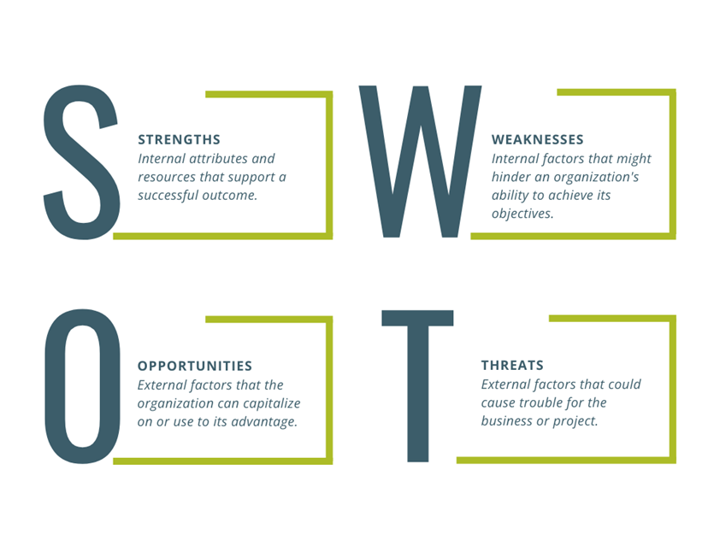

**Figure 2 SWOT Analysis. Created by the author.**

## Enhancing the Innovation potential of Women Entrepreneurs

This part of the Module includes subtopics like: 1) Creative thinking skills 2) Design of the strategic plan for innovation 3) Effective implementation of innovative ideas

### 1. Creative thinking skills

According to Gildi Waisburd, the expert on creativity, key traits of creative people are: flexibility, curiosity, independence, reflection (thinking about what they see and hear), ability to concentrate, perseverance, commitment, sense of humour, ability to overcome difficult situations and conflicts, can see the whole picture, have a list of ideas for a solution to a problem, like to "play" with things, understand the needs of others, set out in detail their task, can tell a story-storytelling. (Waisburd, G., 2013)

**Creative Thinking Skills - A Creative Approach to Innovation**

**Objective:** Teach participants how to unlock their creative potential and generate innovative ideas.  
 **Key Topics:**

Mindset for Creativity (Growth Mindset, Overcoming Mental Barriers)

Divergent vs. Convergent Thinking

Techniques: Brainstorming, SCAMPER, Mind Mapping, 6 Hats, "How Might We?"

**Exercise 1** – Group Work: **Design Thinking & Creative Thinking Skills**

Design Thinking **enhances creative problem-solving** by focusing on empathy, user needs, and iterative prototyping. It involves:

* **Empathy** – Understanding users’ needs deeply.
* **Defining the Problem** – Clearly framing challenges from a human-centred perspective.
* **Ideation** – Brainstorming and generating diverse solutions.
* **Prototyping** – Quickly developing models to test concepts.
* **Testing & Refining** – Gathering feedback and improving solutions.

It shifts thinking from "What can we create?" to "What does the user really need?"

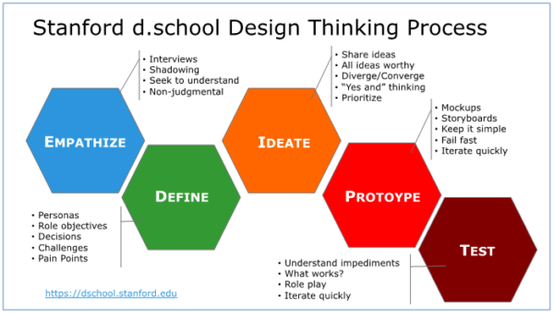

**Figure 3 Stanford d.school Design Thinking Process [12]**

### 2. Design of the strategic plan for innovation

Designing the Strategic Plan for Innovation – From Ideas to Strategy

**Objective:** Guide participants in structuring innovative ideas into a strategic framework.  
**Key Topics:**

* Elements of a Strategic Innovation Plan
* SWOT, PESTLE & Trend Analysis for Innovation
* Setting Innovation Goals & Metrics
* Tools: Job to be Done, Value Proposition, Business Model Canvas, Innovation Roadmap

**Exercise 2** - Group Work: **Draft a Mini Innovation Strategy for a selected company**

Participants explore successful innovations and develop strategic action plans for their imagined businesses.

The exercise includes:

* Brainstorming innovative solutions to business challenges
* Crafting personal action plans for implementing innovations
* Developing and pitching strategic innovation plans (3–5 minutes) for funding consideration

Groups vote on the best innovation, and winners are rewarded. The post-presentation discussion involves critical feedback on the innovation's strengths and areas for improvement. The competitive nature of the exercise highlights the importance of quantitative analysis, qualitative feedback, and effective presentations in securing funding.

**How to draft Innovation Strategy:**

* **Define Vision, Mision, Values**
* **Set Clear Goals & KPIs & Measuring Success**
* **Discover Job to be Done, Pain Gain Model**
* **Define Value Proposition,**
* **Create Canvas Business Model**

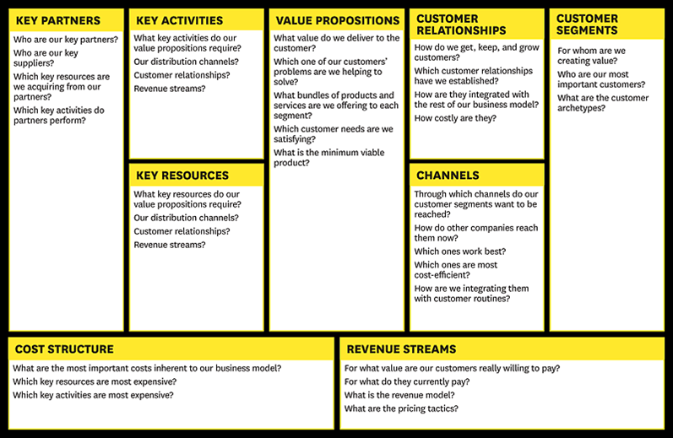

**Figure 4. Business Model Canvas (Source: Osterwalder and Pigneur (2015))[13]**

**Objective:** Equip participants with tools to turn strategies into action and ensure success.

**Key Topics:**

* Overcoming Resistance to Change
* Change Management process
* Leadership & Team Alignment for Innovation Execution

Christensen, C. (1997) and Zhexembayeva, N. (2021) explained the phenomenon of Corporate Narcissism or "We're too good to fail" by describing why large organizations fail to engage in the innovation process: "The decision-making and resource allocation processes that are critical to success organization is the art of listening to customers, carefully monitoring the activities of competitors, and investing resources in designing and building high-quality, high-performance products that will bring more profit. These are the reasons why large organizations fail when faced with disruptive technological changes."

### 3. Effective implementation of innovative ideas

**Objective:** Equip participants with tools to turn strategies into action and ensure success.

**Key Topics:**

* Overcoming Resistance to Change
* Change Management process
* Leadership & Team Alignment for Innovation Execution

Clayton Christensen (The Innovator's Dilemma, 1997), and Nadya Zhexembayeva (Overfished Ocean Strategy: Powering Up Innovation for a Resource-Deprived World, 2021) explained the phenomenon of Corporate Narcissism or "We're Too Good to Fail" by describing why large organizations fail to engage in the innovation process: "The decision-making and resource allocation processes that are critical to success organization is the art of listening to customers, carefully monitoring the activities of competitors, and investing resources in designing and building high-quality, high-performance products that will bring more profit. These are the reasons why organizations fail when faced with disruptive technological changes."

According to Mamula Nikolić, T. (2023)[14] several questions arise - how can we reinvent a business, its processes, business model, and brand, considering the rapid changes in the environment? How can we respond to the demands of consumers, employees, suppliers, business partners, society, and increasingly strong competition?

**Exercise 3** - Group Work: **Create a roadmap for implementing an innovative idea within their organization and a special focus on the change management process according to Kotter.**

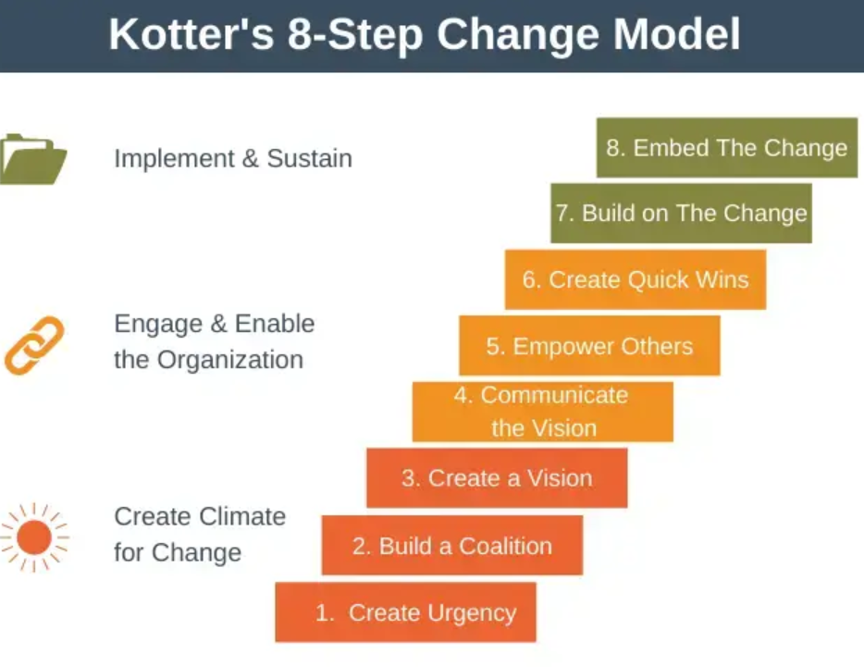

**Figure 5 Kotter's 8-Step Change Model[15]**

# Summing up

**Take-Aways:**

1. Legal Documentation and Financial Statements: Understand the importance of accurate legal documentation and financial statements for maintaining business transparency and securing funding.
2. Company Performance Evaluation: Learn to perform financial and basic ratio analysis to evaluate company performance effectively.
3. Liquidity Ratios: Gain insights into liquidity ratios to assess the short-term financial health of your business.
4. Credit Ratio: Understand credit ratios and their significance in evaluating the creditworthiness of your business.
5. Innovation Funding: Explore available funding opportunities for women’s SMEs and understand the procedures to apply for them.
6. Pitching to Investors: Develop effective pitching skills to present your business ideas and secure investments from potential investors.
7. Net Working Capital Management: Learn how to manage your operational finances effectively by understanding the concept of net working capital.
8. Blockade Verification: Understand the procedures for verifying and addressing potential business blockades.
9. Tax Obligations: Learn about obtaining certifications that confirm the settlement of tax obligations to ensure compliance.
10. Creditworthiness Assessment: Conduct thorough assessments to determine the creditworthiness of your enterprise.
11. Profitability Analysis: Perform detailed profitability analyses to understand your company's financial success and areas for improvement.
12. SWOT Analysis: Utilise SWOT analysis to identify strengths, weaknesses, opportunities, and threats, aiding strategic decision-making.
13. Creative Thinking Skills

* Creativity is essential for innovation, requiring traits like flexibility, curiosity, perseverance, and storytelling.
* A creative mindset involves overcoming mental barriers and using techniques such as Brainstorming, SCAMPER, Mind Mapping, and Six Thinking Hats.
* **Design Thinking** enhances problem-solving by emphasizing user needs, ideation, prototyping, and iterative refinement.
* **Exercise:** Participants engage in group work to apply Design Thinking principles and creative problem-solving techniques.

1. Designing the Strategic Plan for Innovation

* A strategic innovation plan includes elements like SWOT, PESTLE, and trend analysis to assess the business landscape.
* Innovation strategy must align with business vision, mission, values, and measurable KPIs.
* Tools such as **Job to be Done, Value Proposition Canvas, and Business Model Canvas** help structure innovative ideas into actionable strategies.
* **Exercise:** Groups draft a mini innovation strategy for a company, pitch their ideas, and receive critical feedback, fostering strategic thinking and presentation skills.

1. Effective Implementation of Innovative Ideas

* Execution of innovation requires overcoming resistance to change, effective leadership, and team alignment.
* Change management models, such as Kotter's 8-Step Change Model, provide structured approaches for transitioning organizations through innovation.
* Corporate Narcissism can hinder innovation, as seen in the reluctance of large organizations to adapt to disruptive changes.
* Exercise: Participants create a roadmap for implementing an innovative idea in their organization, focusing on change management strategies.
* Self-assessment tool of the innovation potential applicable for SMEs

## Quick self-assessment test of innovation capacity for SMEs based on INNOVATE [16]methodology

1. **Product Development Strategy:**
2. Business Strategy

Strategic planning, defining the mission, vision, and/or clear business focus. Regular preparation of annual plans, analysis of new markets and products

1. Products and Markets

Understanding of competition, awareness of market needs for your product, assortment planning, etc

1. Technology and production

How much does the company track technological changes, and how much effort and resources are invested in improving design, technology, and business processes?

1. Customer focus

To what extent do the company's products/services meet customer needs? Are customer requirements defined before developing a new product? Awareness of laws regulating the market for specific products/services (existence, permits, standards) ...

1. Quality

The existence of quality standards, adherence to quality practices and procedures throughout the company following ISO 9000, presence of quality control in the business system (in which segments), the existence of a TQM (Total Quality Management) program aimed at continuous improvement of development, production, sales, and service activities. Ability to quantify costs of quality/failure.

1. Intellectual property rights

To what extent does the company pay attention to intellectual property protection when developing a new product? Does it have resources for intellectual property protection**?**

1. **Structured product development**

How to create a structure of the product development process, aiming for the rapid realization of the project and maintaining control over the process implementation?

Defined process (to what extent is the product development procedure present and is it present at all? Is each product developed differently? Procedures exist but are simple, and controlled through meetings; the product development process is clear and defined by the Official Control Manual for all phases of the process; there is complete tracking of product status in each phase of the process

Organization (Is there a developed line of responsibility in product development management or is only one manager responsible for the entire process?)

Level of implementation (To what extent are there plans for various types of development projects, decisions are made on an ad hoc basis regarding which processes will accompany which project; are there and to what extent are there rules for various types of projects from major developments to simple adaptations; does the entire company understand the process; are clear criteria for the process that accompanies each project; performance measurement is used for continuous improvement).

1. **Performance measurement**

Is there quantitative performance measurement for product development? project's impact known at the end of the fiscal year or not; are performance regularly measured in each phase of the process or not

1. **Initial project assessment**

How thoroughly are initial assessments of development production costs conducted and compared with sales prices and quantities; to what extent is fully integrated marketing, development, and production evaluation present before any project is approved?**.**

1. **Teamwork**

How do people work together in a team and how successful they are in developing a new product: team selection, organization and functioning?

* Team composition
* Roles and responsibilities
* Training and qualifications
* Management and motivation
* Communication

1. **Tools and techniques**

Availability and application of appropriate tools and techniques such as CAD, SPC, FMEA, in all stages of the product design process, to maximize the effectiveness of the development team

Application

* Quality improvement tools
* Cost reduction tools
* Information technology
* Planning tools
* Product testing and evaluation

1. **Parallel work (on several aspects of the project)**

* **Market, product, process, materials**
* **Product price**
* **Available information**
* **Supply chain partnership**

1. **Project and program management**

How projects and groups of projects are managed to ensure efficient resource allocation; eliminate conflicts and bottlenecks in the process; control costs; adhere to activity schedules

# Success case

**Mrija Ivankovic Jurisic owner of Atelier Marija Handmade**

Marija Ivanković Jurišić is a textile designer and the owner of the weaving studio Marija Handmade. She is a recipient of the Flower of Success for a Woman Dragon award, as well as a recognition from the European Entrepreneurship Network for her successful participation in international textile programmes. Marija Handmade is dedicated to empowering and promoting women's entrepreneurship by engaging women from disadvantaged employment categories in this form of social entrepreneurship.

The work of the Marija Handmade Studio is the result of Marija’s research into traditional handcrafting techniques, intertwined with Serbian folkloric motifs and their stylisation on classic constructions of clothing and functional textile items.

“For weaving our textiles, we use natural fibres such as wool, cotton, silk, hemp, and linen, as well as hand-dyed yarns coloured with pigments from aromatic plants, which are transformed into unique fashion accessories and home textiles. Our mission is to offer you fabrics that allow your skin to breathe and your body to feel its best. We carefully select every thread to create textiles that are good enough to touch you. Weaving, knitting, sewing, dyeing… we truly love every step of the process as we breathe life into these pieces.

Every journey, every adventure, and every lesson we have learned in life—from childhood in Serbia to fashion shows in Sabac, Belgrade, Paris, Bern, The Hague, and Sydney—tells the story of who we are and what we do. Always remember that unique pieces are not made to conceal but to blend with your body. Buy less, but choose better so that it lasts longer.”

# Bibliography and further references

Books:

1. Altman, E. I., Hotchkiss, E., & Wang, W. (2019). Corporate financial distress, restructuring, and bankruptcy: Analyse leverage, risk, and valuation to predict and resolve financial distress (4th ed.). Wiley.
2. Bodie, Z., Kane, A., & Marcus, A. J. (2021). Investments (12th ed.). McGraw-Hill.
3. Bragg, S. M. (2020). Financial analysis: A business decision guide. Accounting Tools.
4. Brigham, E. F., & Ehrhardt, M. C. (2022). Financial management: Theory & Practice (17th ed.). Cengage Learning.
5. Brush, C. G., de Bruin, A., Gatewood, E. J., & Henry, C. (Eds.). (2010). Women Entrepreneurs and the Global Environment for Growth: A Research Perspective. Edward Elgar Publishing.
6. Carter, S., & Marlow, S. (2020). Enterprise and small business: Principles, practice, and policy (4th ed.). Pearson.
7. Clark, D. (2020). The art of start-up fundraising: Pitching investors, negotiating the deal, and everything in between. Wiley.
8. Damodaran, A. (2020). Investment valuation: Tools and techniques for determining the value of any asset (3rd ed.). Wiley.
9. Fabozzi, F. J., & Peterson Drake, P. (2020). Financial ratio analysis: A guide to assessing company strengths and weaknesses. Wiley.
10. Fraser, L. M., & Ormiston, A. (2020). Understanding financial statements (11th ed.). Pearson.
11. Gitman, L. J., & Zutter, C. J. (2022). Principles of managerial finance (15th ed.). Pearson.
12. Higgins, R. C. (2018). Analysis for financial management (12th ed.). McGraw-Hill.
13. Hisrich, R. D., & Peters, M. P. (2002). Entrepreneurship. McGraw-Hill/Irwin.
14. Hisrich, R. D., Peters, M. P., & Shepherd, D. A. (2020). Entrepreneurship (11th ed.). McGraw-Hill.
15. Kawasaki, G. (2020). The art of the start 2.0: The time-tested, battle-hardened guide for anyone starting anything. Portfolio/Penguin.
16. Palepu, K. G., Healy, P. M., & Peek, E. (2020). Business analysis and valuation: IFRS edition (5th ed.). Cengage Learning.
17. Palepu, K. G., Healy, P. M., & Peek, E. (2022). Business analysis and valuation: IFRS edition (6th ed.). Cengage Learning.
18. Penman, S. H. (2021). Financial statement analysis and security valuation (6th ed.). McGraw-Hill.
19. Piercy, N. (2019). Marketing strategy & competitive positioning (7th ed.). Pearson.
20. Ross, S. A., Westerfield, R. W., & Jaffe, J. F. (2021). Corporate finance (13th ed.). McGraw-Hill.
21. Shaxson, N. (2018). The finance curse: How global finance is making us all poorer. Bodley Head.
22. Christensen, C. M. (1997). The innovator's dilemma: When new technologies cause great firms to fail. Harvard Business Review Press.
23. Zhexembayeva, N. (2021). Overfished ocean strategy: Powering up innovation for a resource-deprived world. Berrett-Koehler Publishers.
24. Mamula Nikolić, T. (2023). *Business re-innovation*.
25. Osterwalder, A., & Pigneur, Y. (2010). *Business model generation: A handbook for visionaries, game changers, and challengers*. Wiley.

Journal Articles:

1. Altman, E. I. (2018). Predicting financial distress of companies: Revisiting the Z-score and ZETA models. Journal of Banking & Finance, 91, 1-22. <https://www.sciencedirect.com/science/article/abs/pii/S0378426618300402?via%3Dihub>
2. Gürel, E., & Tat, M. (2017). SWOT analysis: A theoretical review. Journal of International Social Research, 10(51), 994-1006.<https://www.sosyalarastirmalar.com/articles/stadium-similarities-parallelisms-and-projections.pdf>

Reports:

1. OECD. (2016). Financing SMEs and Entrepreneurs 2016: An OECD Scoreboard. OECD Publishing.
2. World Bank. (2014). Women, Business and the Law 2014: Removing Restrictions to Enhance Gender EquaOECD. (2021). Financing SMEs and entrepreneurs 2021: An OECD scoreboard. https://doi.org/10.1787/8cdb4b3b-en
3. OECD. (2022). The missing entrepreneurs 2022: Policies for inclusive entrepreneurship and self-employment
4. OECD. (2021). Tax administration 2021: Comparative information on OECD and other advanced and emerging economies.

Web Resources:

1. European Commission. (2020). Access to Finance for SMEs. Retrieved from <https://ec.europa.eu/growth/access-to-finance_en>
2. International Finance Corporation. (2019). IFC's Work on Access to Finance for Women Entrepreneurs. Retrieved from https://www.ifc.org/wps/wcm/connect/topics_ext_content/ifc_external_corporate_site/gender+at+ifc/priorities/entrepreneurship/
3. OECD Reports: <https://www.oecd.org/>
4. World Bank SME Finance:<https://www.worldbank.org/en/topic/smefinance>
5. European Investment Fund: <https://www.eif.org/index.htm>
6. https://www.coursera.org/lecture/management-skills-international-business/key-concept-kotters-8-step-change-model-wrnUn?utm_medium=sem&utm_source=gg&utm_campaign=b2c_emea_x_multi_ftcof_career-academy_cx_dr_bau_gg_pmax_gc_s2_en_m_hyb_23-12_x&campaignid=20882109092&adgroupid=&device=c&keyword=&matchtype=&network=x&devicemodel=&creativeid=&assetgroupid=6485735763&targetid=&extensionid=&placement=&gad_source=1&gclid=Cj0KCQiAkoe9BhDYARIsAH85cDN1Oz3JmbzDaslmVnbfXrh_9CCpFo53DaWAbgn419EhQvvqoUl6Ob8aAvrMEALw_wcB
7. https://dschool.stanford.edu/resources/getting-started-with-design-thinking

Further Reading:

1. Carter, S., & Marlow, S. (2007). Female entrepreneurship: Theoretical perspectives and empirical evidence. In Entrepreneurship: Frameworks and empirical investigations from forthcoming leaders of European research (pp. 9-20). Emerald Group Publishing Limited.
2. Neergaard, H., & Ulhøi, J. P. (Eds.). (2007). Handbook of Qualitative Research Methods in Entrepreneurship. Edward Elgar Publishing.
3. Harvard Business Review articles on finance and entrepreneurship
4. Financial Times special reports on SME financing
5. McKinsey & Company insights on business finance strategies

Online Courses and Workshops:

1. Harvard Business School Online. (2020). Entrepreneurship Essentials. Available at https://online.hbs.edu/courses/entrepreneurship-essentials/
2. Coursera. (2021). Innovation for Entrepreneurs: From Idea to Marketplace. Available at <https://www.coursera.org/learn/innovation-entrepreneurship>

Organisations and Support Networks:

1. Women’s Business Enterprise National Council (WBENC). Available at <https://www.wbenc.org/>
2. National Association of Women Business Owners (NAWBO). Available at <https://www.nawbo.org/>
3. International Finance Corporation (IFC) – SME Finance <https://www.ifc.org/>
4. European Bank for Reconstruction and Development (EBRD) – Women in Business Programme <https://www.ebrd.com/>
5. Global Entrepreneurship Network (GEN) <https://www.genglobal.org/>
6. WEConnect International – Supporting Women Entrepreneurs <https://weconnectinternational.org/>

# Related training materials

T

# Keywords

1. Legal Documentation
2. Financial Statements
4. Funding Opportunities
6. Financial Analysis
7. Liquidity Ratios
8. Credit Ratios
9. Creditworthiness
10. Innovation Funding
12. Investor Pitching
13. Working Capital
14. Tax Compliance
15. Profitability Analysis
17. Creative Thinking
18. Design Thinking
20. Innovation Strategy
21. Business Model Canvas
22. Value Proposition
23. Trend Analysis
24. Leadership in Innovation
26. Risk Management
27. Financial Health
28. Operational Finances
29. Strategic Decision-Making



##### Website:

##### www.refem.eu

##### Email:

##### hetfa_re-fem@hetfa.eu

##### Facebook:

##### www.facebook.com/REFEM0

##### Twitter:

##### @RE-FEM project

##### Linkedin:

##### www.linked.com/RE-FEM

Funded by the European Union. Views and opinions expressed are however those of the author(s) only and do not necessarily reflect those of the European Union or the European Education and Culture Executive Agency (EACEA). Neither the European Union nor EACEA can be held responsible for them.

1. Brigham, E. F., & Ehrhardt, M. C. (2022); Hisrich, R. D., Peters, M. P., & Shepherd, D. A. (2020)
2. Gitman, L. J., & Zutter, C. J. (2022); Palepu, K. G., Healy, P. M., & Peek, E. (2022); Damodaran, A. (2020)
3. Ross, S. A., Westerfield, R. W., & Jaffe, J. F. (2021); Fabozzi, F. J., & Peterson Drake, P. (2020)
4. Altman, E. I., Hotchkiss, E., & Wang, W. (2019); Bodie, Z., Kane, A., & Marcus, A. J. (2021)
5. Carter, S., & Marlow, S. (2020); OECD. (2022)
6. Clark, D. (2020); Kawasaki, G. (2020)
7. Higgins, R. C. (2018); Fraser, L. M., & Ormiston, A. (2020)
8. OECD. (2021); Shaxson, N. (2018)
9. Altman, E. I. (2018); Bragg, S. M. (2020)
10. Penman, S. H. (2021); Palepu, K. G., Healy, P. M., & Peek, E. (2020)
11. Gürel, E., & Tat, M. (2017); Piercy, N. (2019)
12. More information can be found at: https://dschool.stanford.edu/resources/getting-started-with-design-thinking
13. Osterwalder, A., & Pigneur, Y. (2010). *Business model generation: A handbook for visionaries, game changers, and challengers*. Wiley.
14. Mamula Nikolić, T. (2023). *Business reinnovation*.
15. More information can be found at: https://www.coursera.org/lecture/management-skills-international-business/key-concept-kotters-8-step-change-model-wrnUn?utm_medium=sem&utm_source=gg&utm_campaign=b2c_emea_x_multi_ftcof_career-academy_cx_dr_bau_gg_pmax_gc_s2_en_m_hyb_23-12_x&campaignid=20882109092&adgroupid=&device=c&keyword=&matchtype=&network=x&devicemodel=&creativeid=&assetgroupid=6485735763&targetid=&extensionid=&placement=&gad_source=1&gclid=Cj0KCQiAkoe9BhDYARIsAH85cDN1Oz3JmbzDaslmVnbfXrh_9CCpFo53DaWAbgn419EhQvvqoUl6Ob8aAvrMEALw_wcB
16. The INNOVATE methodology is a diagnostic tool developed within the EU-funded ICIP project, which was implemented in Serbia from 2011 to 2012 under the leadership of the company G.f.A. Its goal was to encourage Serbian enterprises to improve innovation management and enhance competitiveness. This tool builds on existing, proven diagnostic tools for innovation and is complementary to similar tools, including the IMP³rove benchmarking tool used in the EU. INNOVATE was originally developed as a Microsoft Excel-based tool but is now also available as an online tool on various websites in Serbia.